

Code Craft

**Company Overview**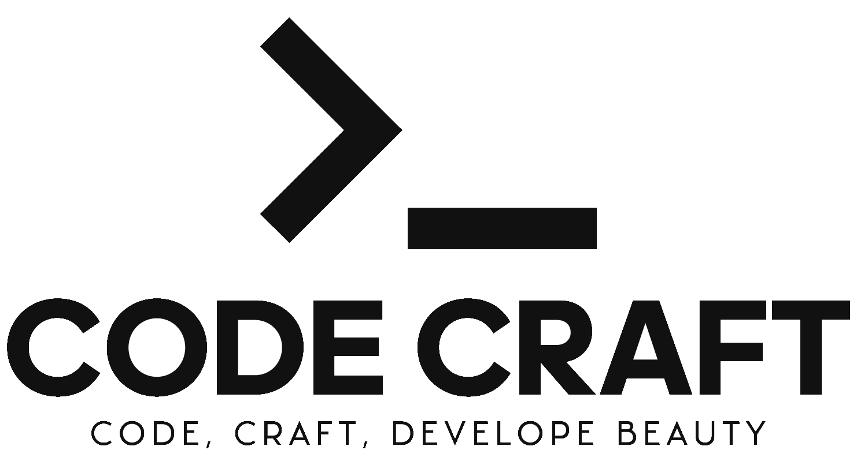

Group Assignment  
Group: NTV

Executive Summary

Code Craft stands as a paradigm of digital craft, merging Ireland's creative legacy with state-of-the-art web development. Our offerings cross custom web design to comprehensive e-commerce solutions, all while prioritizing innovation and client satisfaction.

Table of Contents

Introduction 4

Company Background 4

Project Initiation 4

Scope and Objectives 4

Company Structure 4

Organizational Chart 4

Roles and Responsibilities 5

CEO (Chief Executive Officer): Vladislav Cernega 5

Web Development Manager: Nurbolot Kanybek Uulu 5

Design and User Experience (UX) Manager: Tilek Ulan Uulu 5

Management Leadership Style 5

Market Analysis 5

Industry Overview 5

Competitive Landscape 5

Target Market Identification 5

Market Needs and Trends 5

SWOT Analysis 6

Strengths – Technical Expertise and Innovation 6

Weaknesses – Market Presence and Service Diversification 6

Opportunities – Market Expansion and Technological Advancements 6

Threats – Industry Competition and Technological Obsolescence 6

Planning Process 6

Project Management Approach 6

Milestone Definition and Scheduling 6

Gantt Chart Presentation 6

Risk Management Plan 6

Development Process 6

Technology Selection 6

Design and Prototyping Methodology 6

Development and Coding Standards 6

Quality Assurance and Testing Procedures 6

Managerial Oversight 6

Task Delegation and Monitoring 6

Interdepartmental Communication 6

Feedback and Performance Evaluation 6

Document Management and Control 6

Sales and Marketing Strategy 6

Marketing Plan Development 6

Branding and Positioning 6

Social Media Outreach 6

Customer Engagement and Retention Strategies 6

Research and Development Innovations 6

Market Research Techniques 6

Product Development Lifecycle 6

Prototyping and User Testing 6

Innovation and Improvement Mechanisms 6

Website and Digital Presence 7

Website Design and Functionality 7

User Experience Optimization 7

SEO and Online Visibility 7

Analytics and Performance Review 7

Brand Kit and Corporate Identity 7

Design Elements and Guidelines 7

Business Card and Letterhead Design 7

Corporate Branding Across Platforms 7

Manager Feedback and Analysis 7

Review of Departmental Submissions 7

Critical Analysis of Task Efficiency 7

Recommendations for Improvement 7

Conclusion and Reflection 7

Project Achievements and Learnings 7

Team Performance and Contribution Review 7

Strategic Recommendations for Future Projects 7

Appendices 7

Market Analysis Data 7

SWOT Analysis Detailed Charts 7

Gantt Chart and Planning Documents 7

Design Mockups and Prototypes 7

Survey Questionnaires and Results 7

References 7

# Introduction

## Company Background

Code Craft is a premier web development company that crafts elegant solutions for businesses and individuals. Our core competencies include custom website development, e-commerce solutions, web application development, responsive design, and content management systems. We are commited to driving digital growth through innovaFve technology that delivers exceptional web experiences. Our dedication to quality, innovation, and client satisfaction sets us apart, making us the ideal partner for anyone looking to succeed in the digital realm.

## Project Initiation

Our initiation process is deeply founded in team synergy. At Code Craft, we connect the collective experience of our team, encouraging each member to contribute their personal ideas and skills. This collaborative environment is the foundation upon which innovative solutions are created, personalized to meet the special needs of our customers. Our spirit, “Code Craft,” is a testament to our delicate approach to every project, crafting web solutions that are as crafty as they are precise.

## Scope and Objectives

The scope of Code is to deliver top-end cutting-edge web solutions. Our objectives are clear: create a project where all the ends are connected and fully driven by each team member enthusiasm and experience.

# Company Structure

## Organizational Chart

The organization chart of Code Craft lays out in a hierarchial pyramid of leadership within the company. At the peak is the CEO, followed by Design and UI/UX Manager on same floor with Web Development Manager. Eash role is crucial to the company operations and are collaborative working towards the succes of Code Craft.

## Roles and Responsibilities

### CEO (Chief Executive Officer): Vladislav Cernega

* Directs and defines the company's strategic vision.
* Represents Code Craft in all external communications and partnerships.
* Ensures the smooth functioning of internal operations while maintaining the company's cultural integrity.
* Holds the authority to make pivotal company decisions and approve major projects.

### Web Development Manager: Nurbolot Kanybek Uulu

* Oversees the entire spectrum of web development projects from inception to completion.
* Works in tandem with the CEO to align project strategy with company goals.
* Keeps abreast of the latest trends and technologies in web development.
* Ensures coordination between the development team and the design and UX teams for seamless project delivery.

### Design and User Experience (UX) Manager: Tilek Ulan Uulu

* Leads the design team to create intuitive and aesthetically appealing website interfaces.
* Collaborates with the web development manager to integrate design and functionality.
* Stays updated with the latest UX trends to optimize user interaction and conversion rates.
* Manages user feedback and implements iterative design improvements based on testing and analysis.

## Management Leadership Style

At Code Craft, leadership is exercised through a blend of collaborative effor. The CEO, Vladislav Cernega, promotes a culture of shared ideas and responsibility. Leadership within the web development and design departments is driven by a collective effor of the managers, Nurbolot Kanybek Uulu and Tilek Ulan Uulu, proving leadership through continuous learning, adaptability, and a excitement drive.

# Market Analysis

## Industry Overview

The software development industry is highly competitive, with numerous companies offering a range of services, from web and mobile application development to custom software solutions. In this section, we will conduct an in-depth market analysis of ten

noticeable software development companies. These companies are: Imaginary Cloud, ChopDawg.com, AllianceTek, Emergent Software, Savas Labs, One Beyond, Pixated, Tech Alchemy, Scopic, Apdami.

## Competitive Landscape

* **Imaginary** **Cloud**: Known for user-centric design and scalable solutions.
* **ChopDawg**: Specializes in crafting digital products for startups and enterprises.
* **AllianceTek**: Provides end-to-end software development services with a focus on efficiency.
* **Emergent** **Software**: Offers a wide range of development services, including custom software and application development.
* **Savas** **Labs**: Known for its expertise in Drupal development and web application services.
* **One** **Beyond**: Specializes in creating innovative and customized software solutions.
* **Pixated**: Focuses on creating engaging and interactive digital experiences.
* **Tech Alchemy**: A technology consultancy offering solutions in software development and AI.
* **Scopic**: Known for its global software development services, including virtual and augmented reality applications.
* **Apdami**: Specializes in creating custom software solutions for businesses.

# SWOT Analysis

## Strengths – Technical Expertise and Innovation

### Specialized Expertise:

* Custom website development
* E-commerce solutions
* Web application development
* Responsive design
* Content management systems

### Innovation and Technology Focus:

* Commitment to digital growth through innovation
* Leveraging cutting-edge technology for web development
* Reputation for excellence and attracting diverse clients

### Client-Centric Approach:

* Dedication to quality and innovation
* Building long-term relationships
* Garnering positive testimonials

### Elegance in Solutions:

* Crafting aesthetically pleasing and functionally effective websites
* Elevating user experience for clients

Code Craft stands out for its particular expertise in different aspects of web solutions, dedication to innovation and technological progress, client-oriented solutions, and elegant key design. These strengths together makes Code Craft as a competent, progresive and client-centred company in the web industry.

## Weaknesses – Market Presence and Service Diversification

### Limited Service Offerings:

* Narrow range of services
* Need for diversification to mitigate risks and seize new market opportunities
* Suggestion for strategic approach to diversification for long-term growth

### Market Visibility:

* Limited visibility in the market
* Suggestion to augment marketing efforts to reach a wider audience and attract more clients

Code Craft's primary weaknesses is in limited market visibility and narrow range of services. While it advances in its core competencies, expanding range of services can create more revenue streames and cover some vulnerabilities. Additionally, enlarging its market visibility through an advanced marketing company can help attract a broader base of clients. Mentioning these weaknesses is vital for the company's long-term progress and resitance in a such competitive market.

## Opportunities – Market Expansion and Technological Advancements

### Market Expansion:

* Expanding into new geographical regions or specific industry sectors
* Strengthening competitive positioning and increasing market share

### New Technologies:

* Keeping hand on pulse of emerging technologies
* Integrating new
* Meeting evolving client needs
* Maintaining competitiveness in market

### Partnerships and Collaborations:

* Forming strategic partnerships with businesses or marketing agencies
* Sharing expertise and resources
* Enhancing value proposal and achieving mutual progress

Code Craft’s main opportunities for growth and expansion in marked are multi-sided. Including new, most up-to-date technologies can provide a competitive edge and meet evolving client demands. Furthermore, strategic partnerships and different alliances can lead to an exponential merged growth. These opportunities, can enhance Code Craft’s global market position and ensure a long-term success.

## Threats – Industry Competition and Technological Obsolescence

### Competition:

* Necessity of continuously monitoring competitors in the web development industry
* Identifying areas for improvement and opportunities to differentiate from competitors

### Rapid Technological Changes:

* Challenge of keeping up with the quickly evolving technological background
* Need for regular training and development programs to maintain a competitive edge

### Client Expectations:

* Importance of consistently meeting client expectations
* Risk of client dissatisfaction and loss of clients
* Emphasis on utilizing strengths, addressing weaknesses

Code Craft faces significant threats in the form of huge competition, quick technological progress, and high client expectations. Addressing these threats effectively is vital for Code Craft's ongoing success and long-term growth.

# Planning Process

## Project Management Approach

Our project management approach at Code Craft is fixed, promoting adaptive planning, evolutionary development, early delivery, and continual improvement, making sure all the deadlines are cleared and finished not in their vicinity.

## Milestone Definition and Scheduling

Defining project milestones is a crucial aspect for our planning process. Timetables are set after a in-depth analysis of project, making sure that they are realistic and achievable.

## Gantt Chart Presentation

Gannt Chart is a visual representation of the project schedule, with clearly definied milestones, deadlines and tasks assigned to each team member.

### First Checkpoint

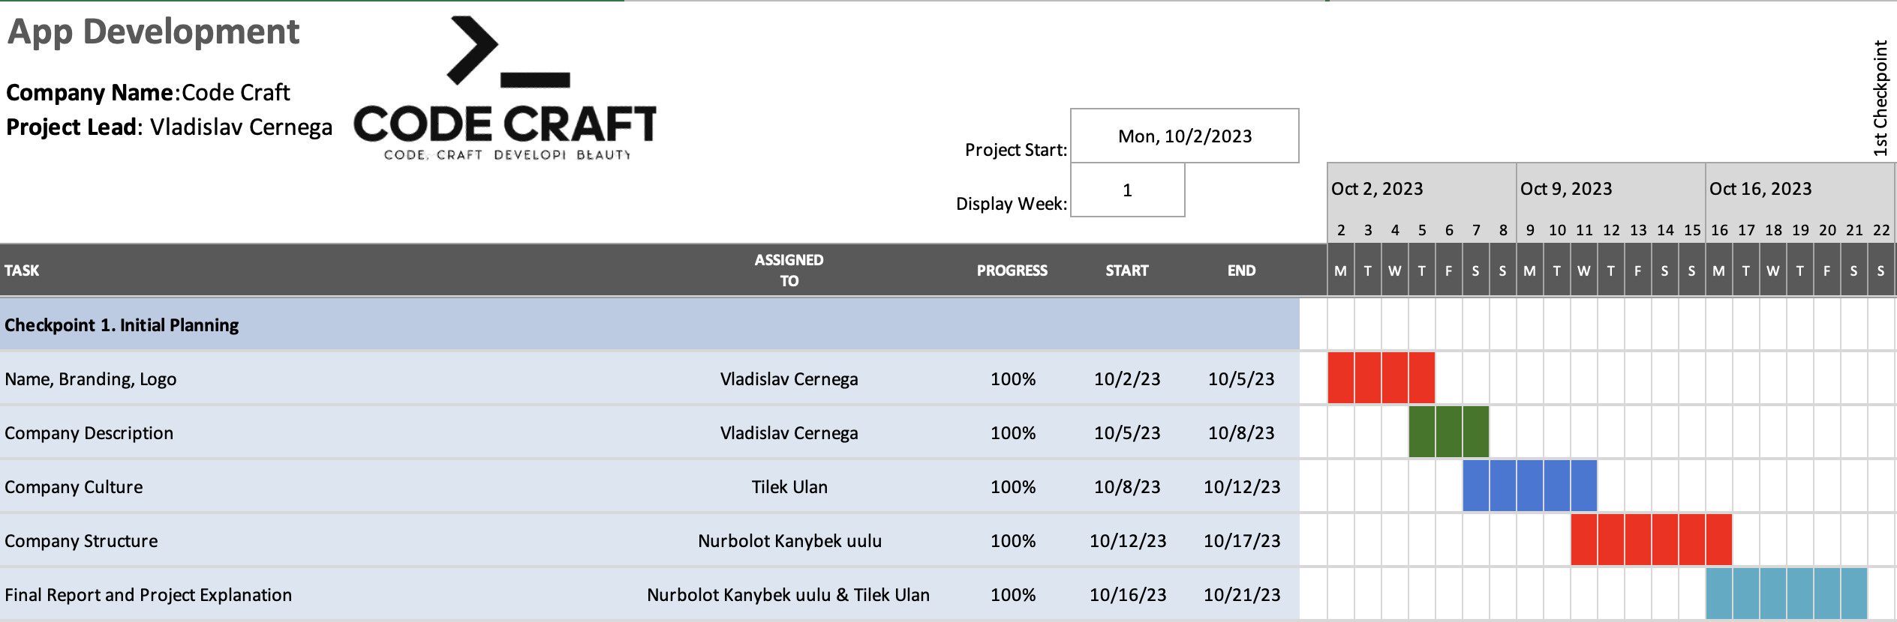

Figure 1. Gantt Chart for 1st Checkpoint

### Second Checkpoint

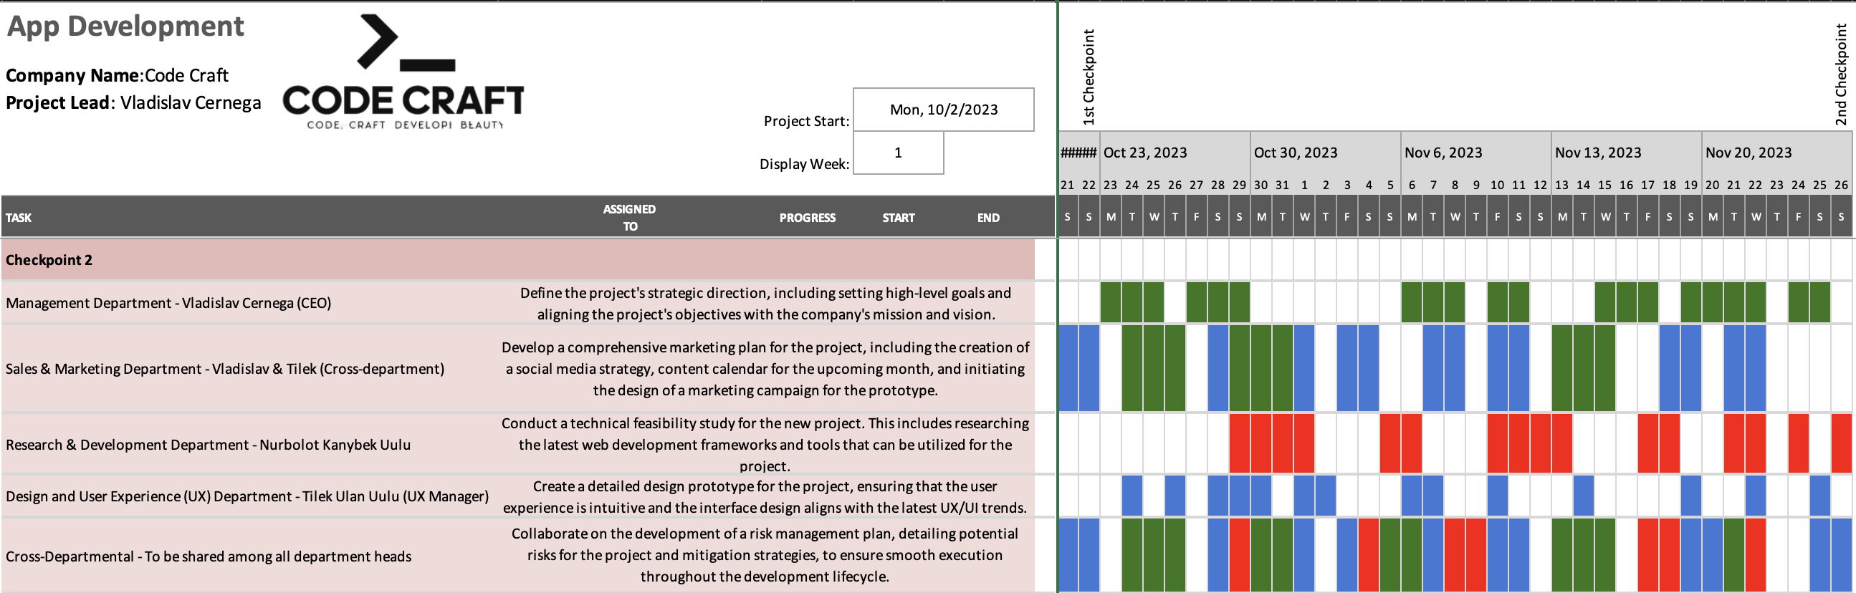

Figure 2. Gantt Chart for 2nd Checkpoint

# Website and Digital Presence

## Website Design

This section of the document provide visual evidence of the work and services offered by Code Craft on their personal website, in form of snapshots of the websites they have developed. That is a landing, grid-layouted page, that fully shows the services offered by Code Craft, their Online Academy, developed mobile App and “About Us” section.  
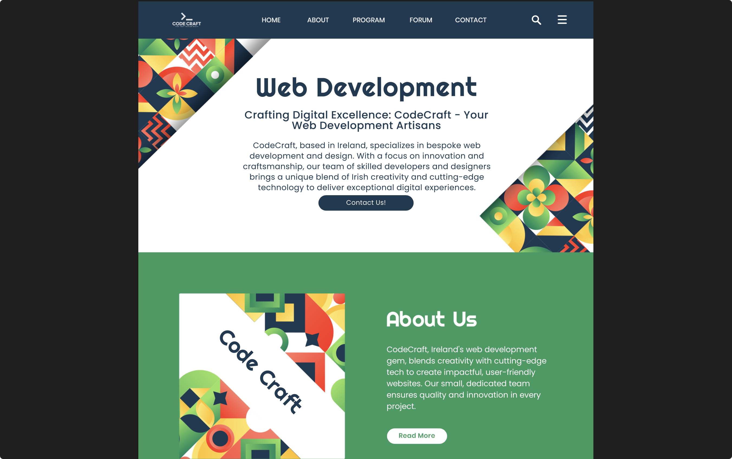

Snapshot 1. Logo, header-menu and Introductive block

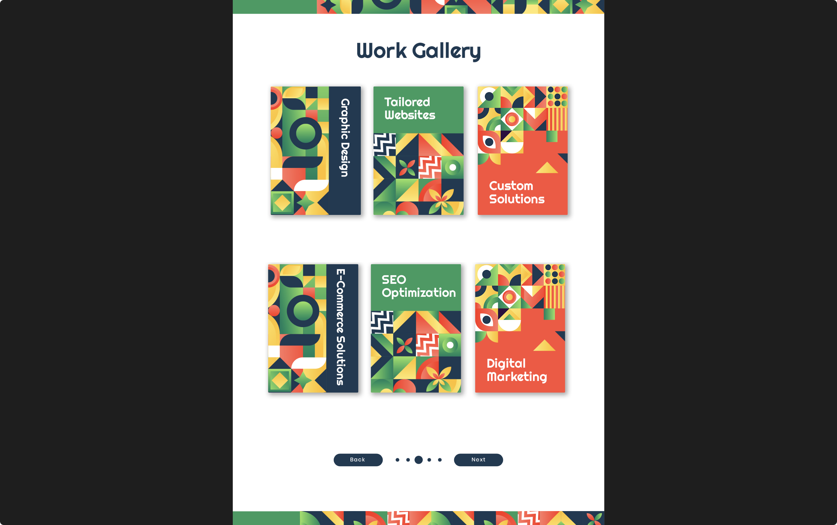

Snapshot 2. Work Gallery that showcases our Services

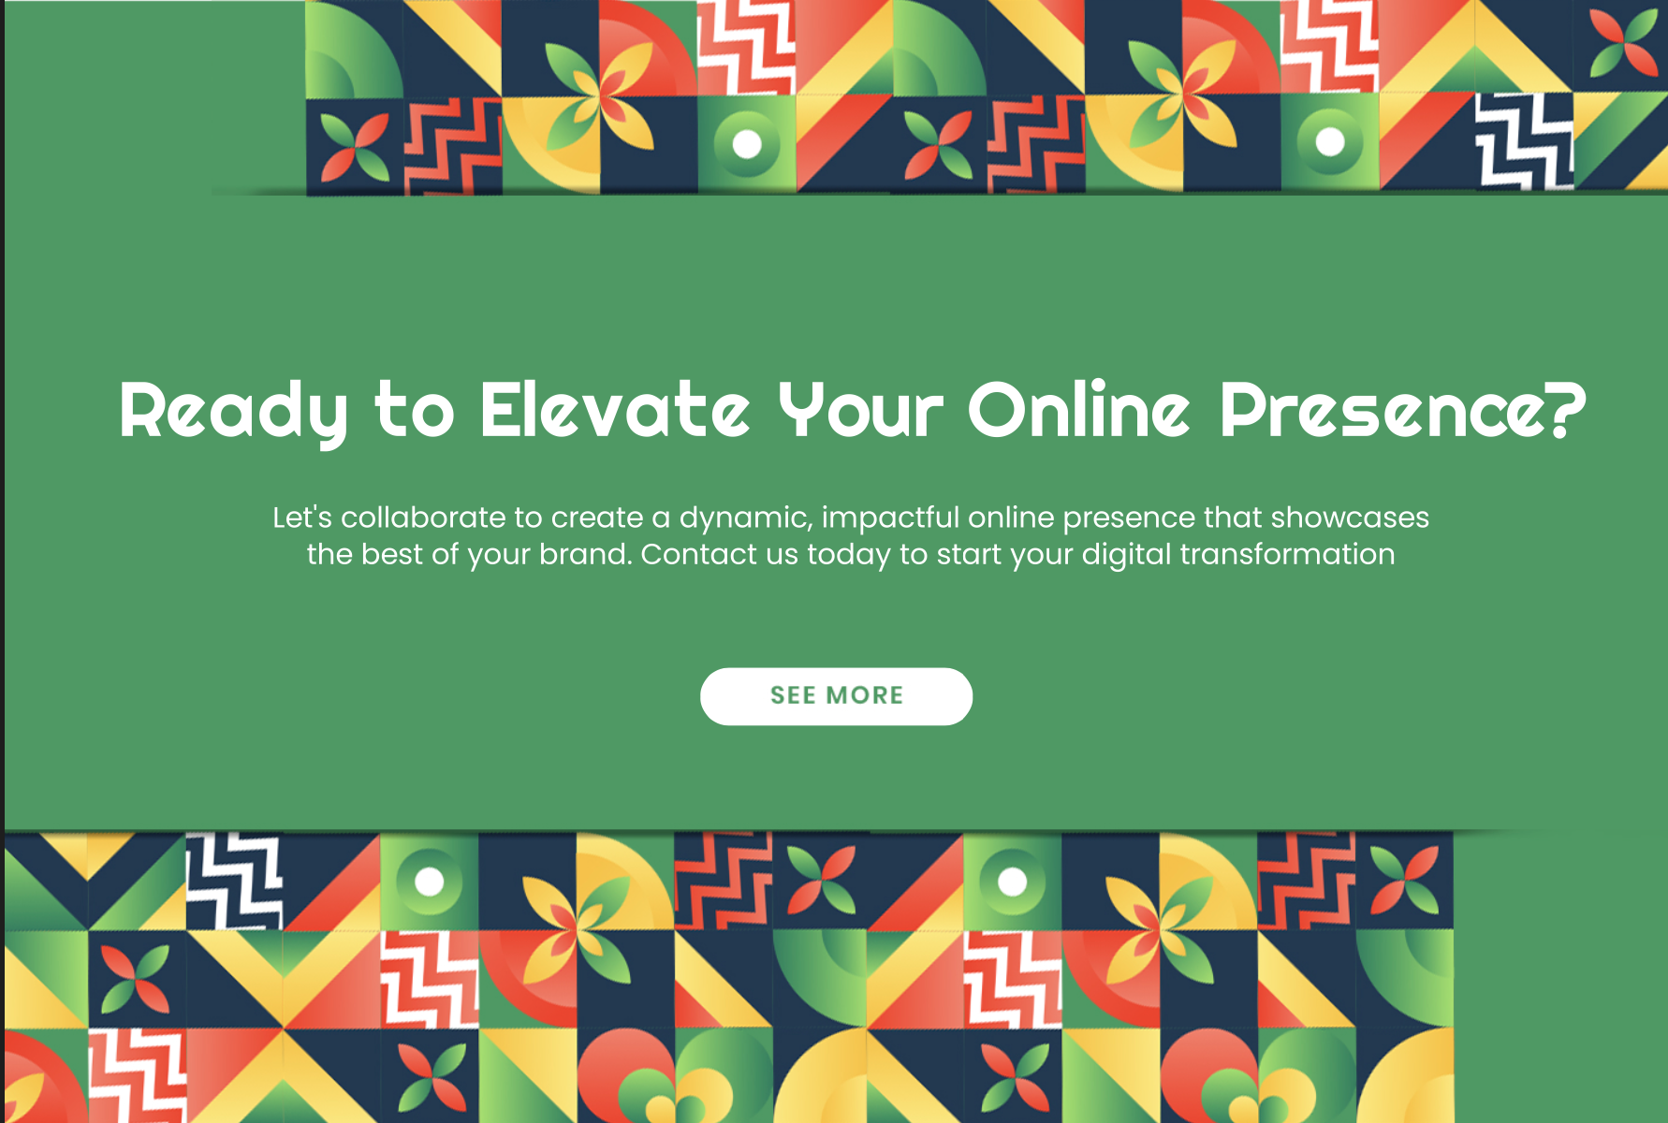

Snapshot 3. Call-To-Action Button with a clearly labelled description

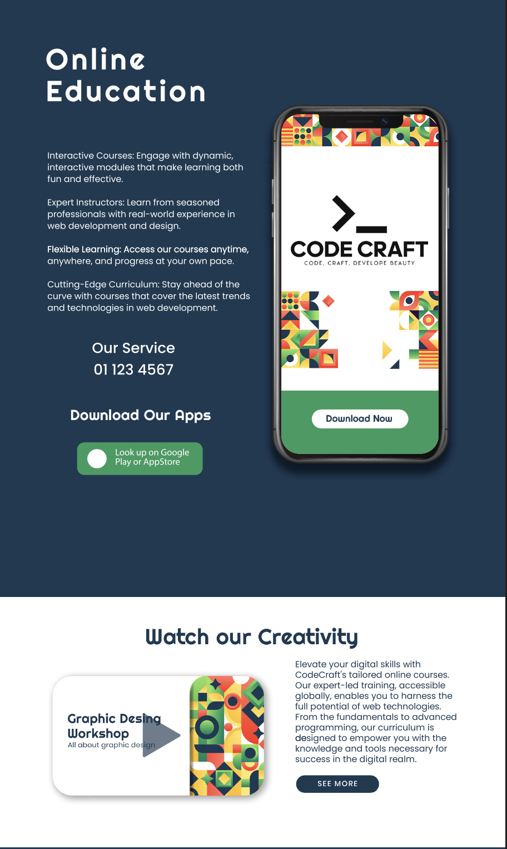

Snapshot 4. Our Online Education Platform, Mobile Educational Ap and Graphical Design Workshop

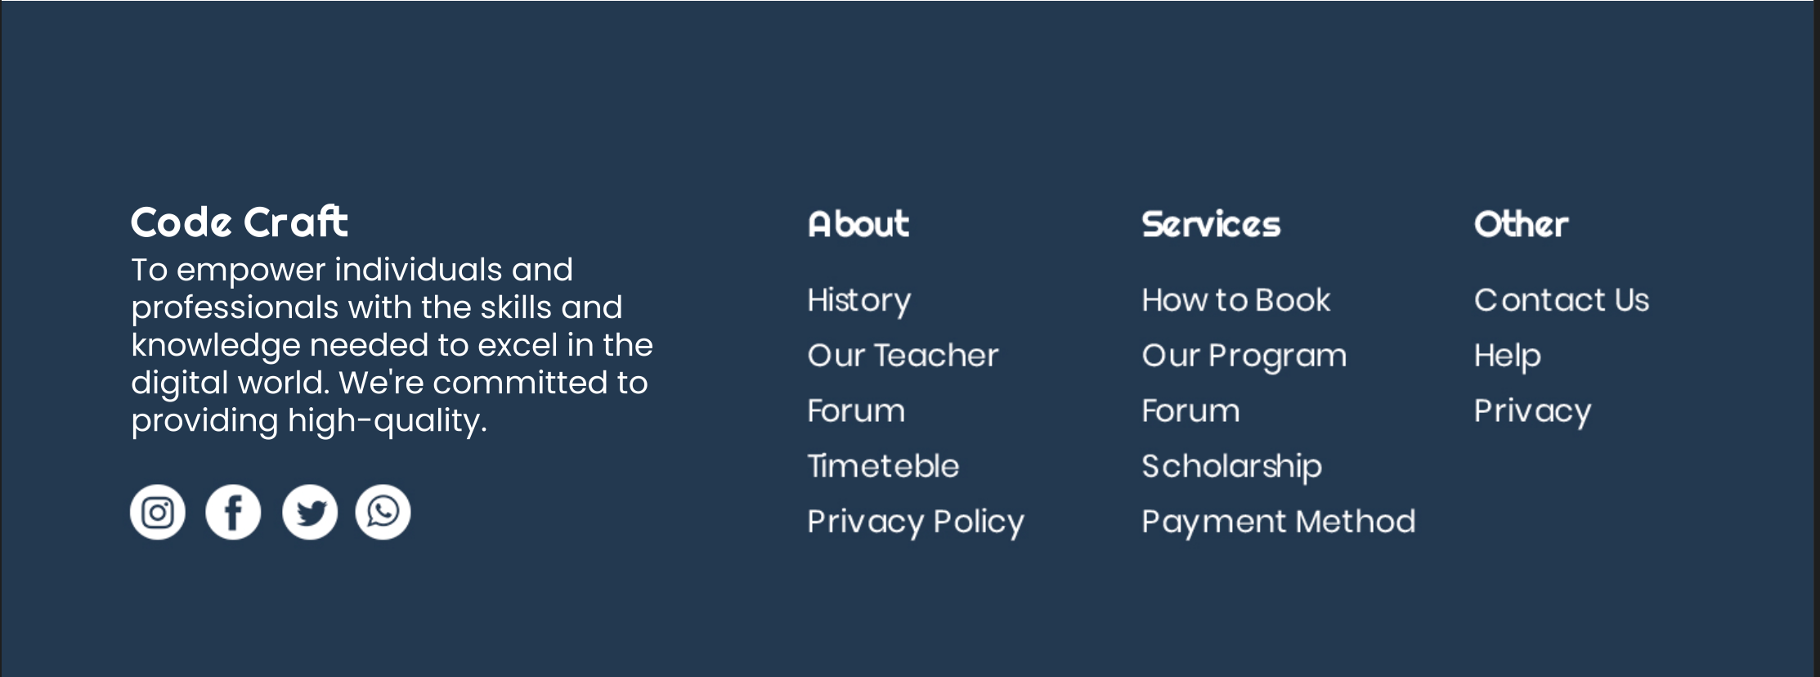

Snapshot 5. Footer that contains all the socials, legal-required pages and less-used web-pages

# Brand Kit and Corporate Identity

## Logo

### Logo Color Schemes



Logo 1. Suitable for Dark Themes



Logo 2. Suitable for Light Themes

### Logo Description

The logo itself contain the company name “Code Craft”, slogan “Code, Craft, Develope Beauty”, and a pair of symbols, that programmers recognise from far “>_” that represents command line prompt, showing that at “Code Craft” coding is at the heart of everything.

## Business Card and Letterhead Design

### Business Cards Variations

Business Card 1. CEO Vladislav Cernega

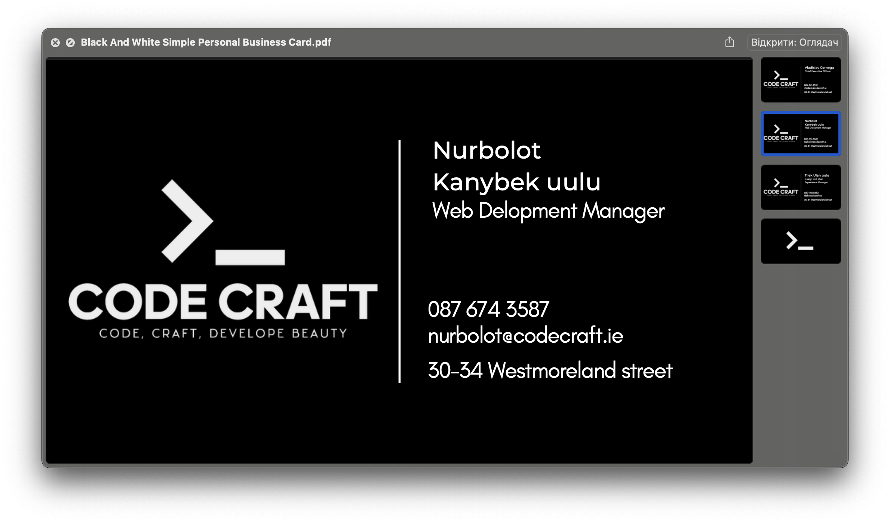

Business Card 2. Web Development Manager. Nurbolot Kanybek Uulu

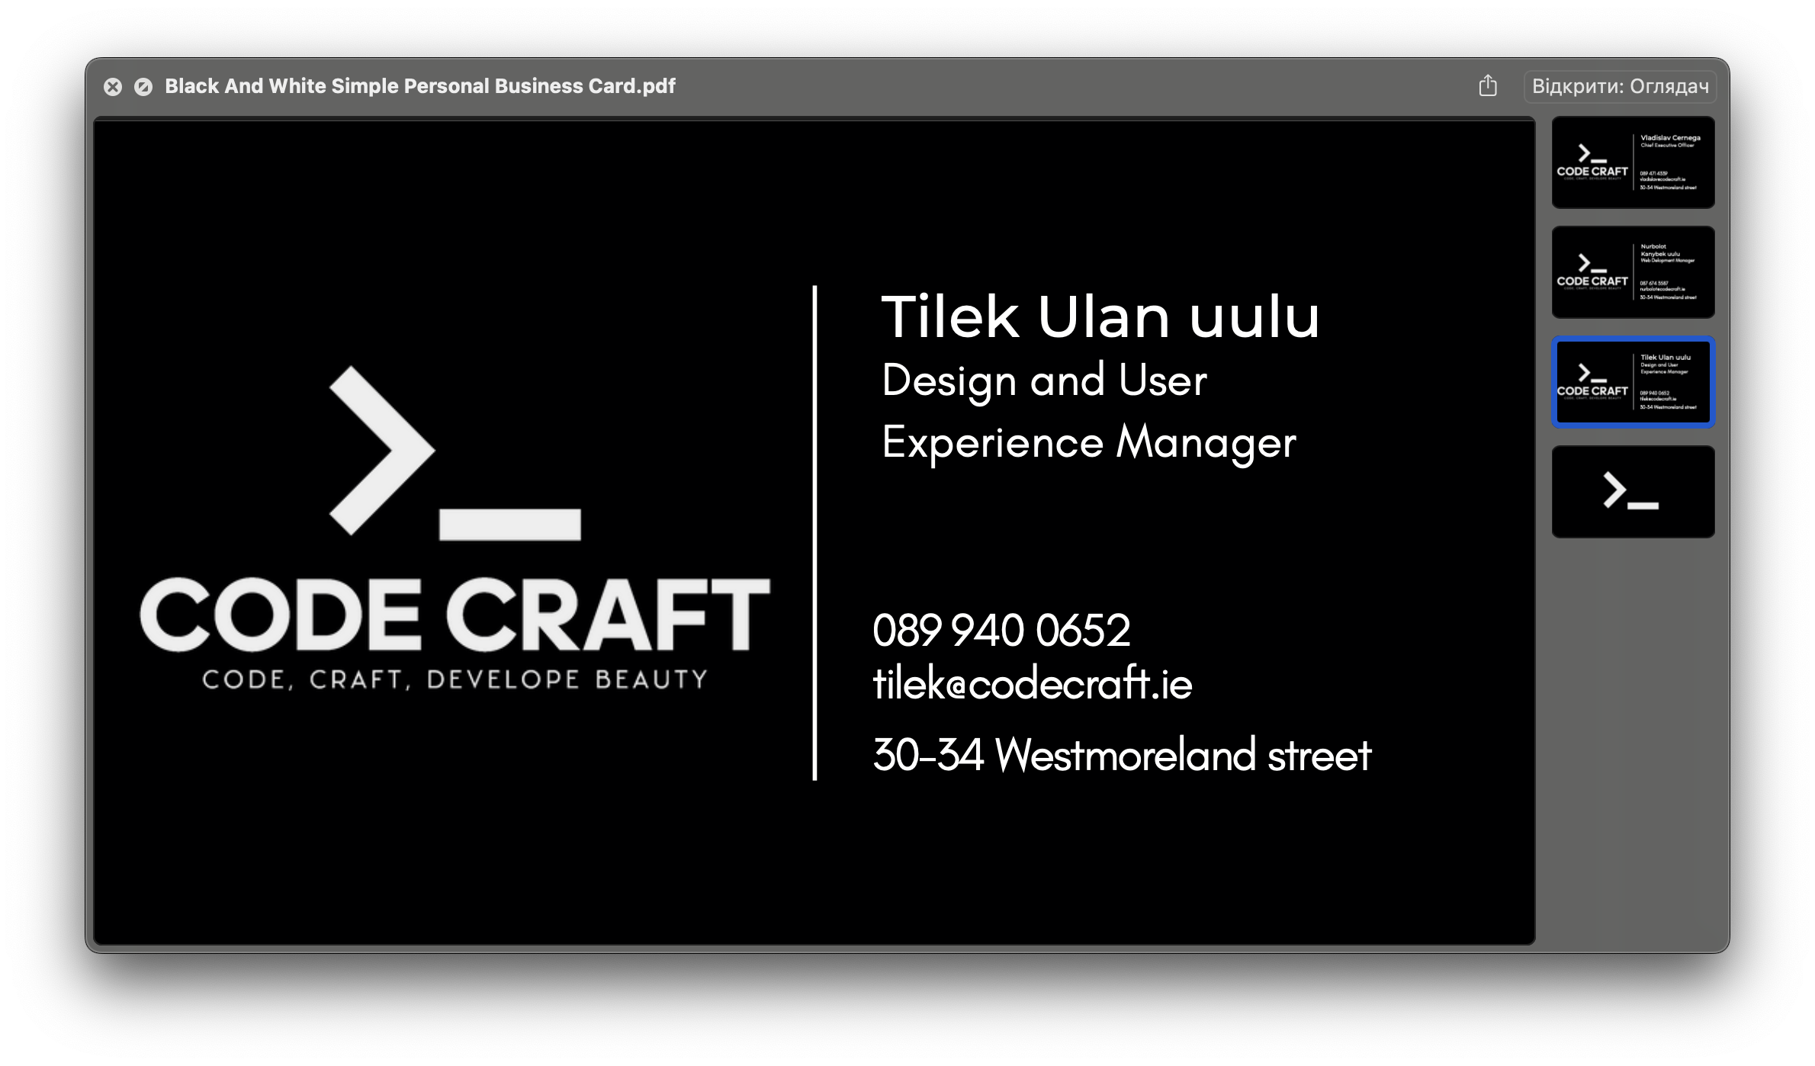

Business Card 3. Design and UX Manager Tilek Ulan Uulu

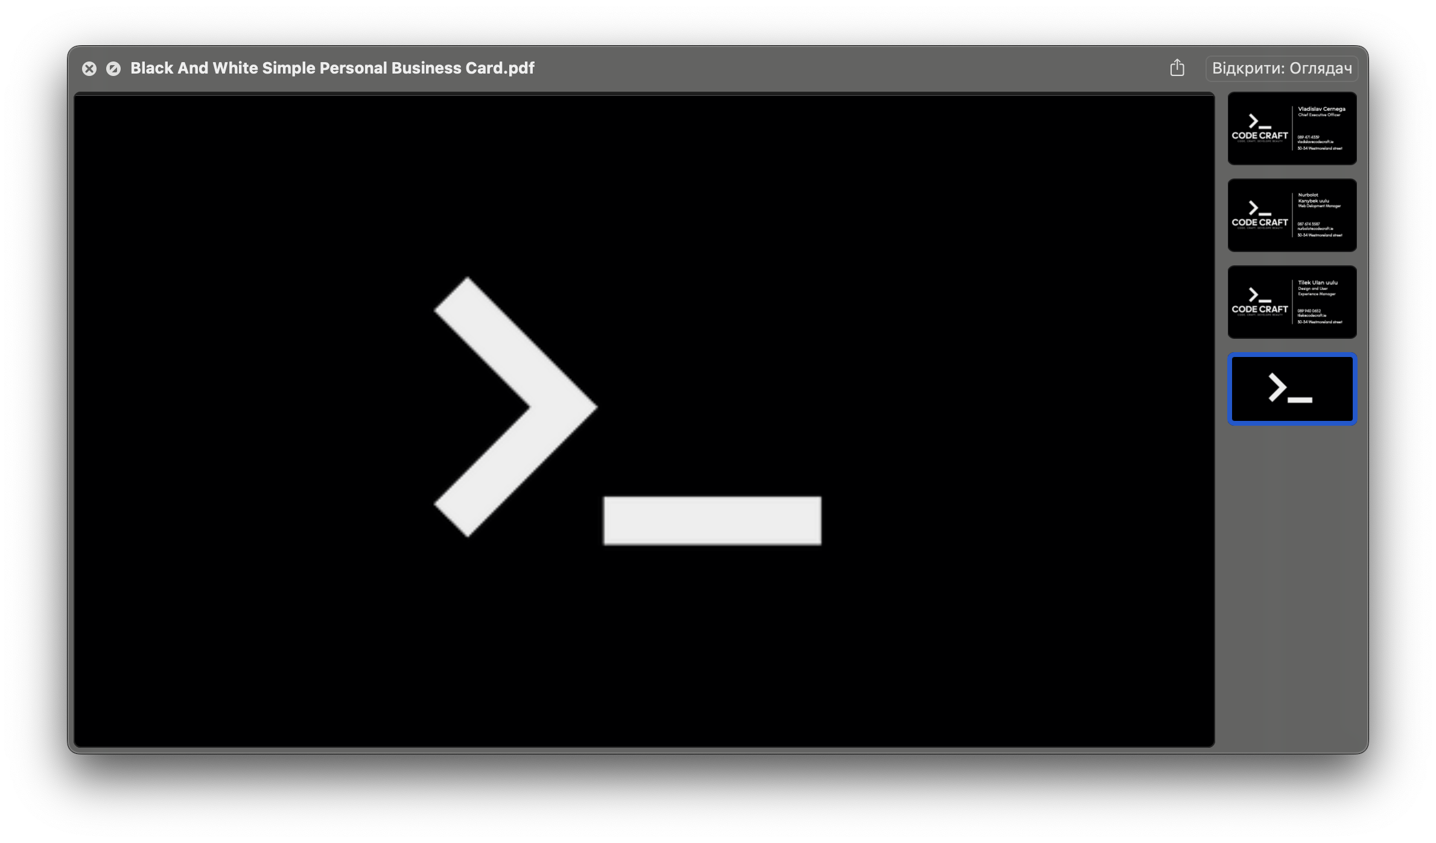

Business Card 4. Reverse Side of All Cards

## Corporate Branding Across Platforms

# Manager Feedback and Analysis

## Review of Departmental Submissions

## Critical Analysis of Task Efficiency

## Recommendations for Improvement

# Conclusion and Reflection

## Project Achievements and Learnings

## Team Performance and Contribution Review

## Strategic Recommendations for Future Projects

# 

# References

**GitHub Repository**

Code Craft Team. (2023). TTM_CA2 Repository. Available at: https://github.com/wolketich/TTM_CA2/tree/main [Accessed 5 November 2023].

**Gantt Chart Tool**

Vertex42.com. (2023). Simple Gantt Chart. Available at: https://www.vertex42.com/ExcelTemplates/simple-gantt-chart.html [Accessed 8 October 2023].

**Google Forms Survey**

Code Craft Team. (2023). Customer Feedback Survey. Available at: https://forms.gle/1pyRsot8sZzUqWad9 [Accessed 18 November 2023].

**Canva Business Cards and Letterheads**

Code Craft Team. (2023). Business Card and Letterhead Designs. Created using Canva. Available at: https://www.canva.com/ [Accessed 20 November 2023].